* fGit is **decentralized or distributed (DVCS)** system but can be used as centralized
* The **Repository** : Collection of files managed by git and all version (history)
* Folder where we initialized git or content files in our storage known as **Working Directory or workspace**
* **Commits :** snapshot of file, create a timeline of changes in **branch,** git repo have atleast one branch known as **master branch**
* **GitHub:** git hosting/cloud service for unlimited public repo with no private repo but in business model, we can choose to have private repo also

Install GIT 2:

# rpm -ivh endpoint-repo.1.7.rpm

**# yum install git**

# git --version

Create GIT repo or initialized git:

# mkdir myprojects

# cd myprojects

**# git init demo**

# cd demo

# ls -a (there folder .git, that is git repo)

Set identity to git, that recorded in version log

**# git config --global user.name “Vimal Daga”**

**# git config --global user.email “**[**vdaga@lwindia.com**](mailto:vdaga@lwindia.com)**”**

Git States with Local:

**Working Directory** : all files present in above “demo” folder

**Staging Area** : file preparing for commit, first store in staging area, then only we can commit

**Repository/Commit History** : committed with version or save changes to git repo

Git States with Remote:

**Remote State** : repo shared to centralized system like GITHUB

# cat > test.txt

First line

**# git status**

Put file in the staging area, without putting file here, we can't create commit history

**# git add test.txt**

Send file to repo/commit area, here we have created snapshot of file means version of file

**# git commit -m “first comment” text.txt**

To check all version of file, every commit they provide commit id

**# git log test.txt**

See details of log

**# git show commitID**

We can use commit id’s to see the diff in 2 version

**# git diff id1 id2**

Remove git repo

**# rm -rf .git**

Again create git repo in existing project, go to project folder

**# git init**

Add all file in staging area

**# git add .**

Add all file in commit area

**# git -m “comment” commit .**

Create new file, that is not by default tracked by git

# touch new.txt

Show tracked file by git

**# git ls-files**

Staging and Committing file in one command : Express commit

**# git commit -a -m “comment” file.txt**

Note: not all version of git support this

**HEAD Markers** : Special Markers Like pointers, points to last commit of current branch

How to make file untracked or removed from staging area:

**# git reset HEAD new.txt**

Rollback file data to any point in time:

# git log file.txt

Get commit id, at what point we want to rollback

**# git reset commitID file.txt**

**# git checkout -- file.txt**

Get clone of project over the network using ssh:

**# git clone root@remoteip:/myprojects/demo**

Get git help of subcommand:

**# git help log**

**# git log --oneline --graph --decorate --all**

Create alias in git:

**# git config --global alias.hist “log --oneline --graph --decorate --all”**

**# git config --global --list**

**# git hist**

**# git hist test.txt**

Rename file in git

**# git mv test.txt testnew.txt**

**# git commit -m “comment rename” testnew.txt**

**# git commit -m “commit delete” test.txt**

Delete file in git

**# git rm file.txt**

**# git commit -m “comment delete” file.txt**

**# git commit -m “commit delete” file.txt**

Managing file deleting or copy from outside working directory:

# cp outfile.txt demo/

# rm text.txt

To update git for deletion

**# git add -u**

For all modification

**# git add -A**

**# git commit -m “comment” .**

Excluding file to untracked by git:

Let say, we want to ignore all file with png extension

**# cat > .gitignore**

**\*.png**

**# git add .gitignore**

**# git commit -m “ignored” .gitignore**

**# touch my.png**

**# git status**

**Branching:** timeline of commits, by default branch is master, we can create several branch from master branch

**Merge:** merge other branch to master

**Fast forward merge:** simplest case, like never branched , commits on destination, can be disabled

**Automatic merge:** non-conflicting merge detected, preserves both timelines, merge commit on destination

**Manual Merge:** automatic merge not possible, conflicting merge state, changes saved in merge commit

List of all branches:

**# git branch**

Note: “*” here means current branch name

# cat > web.txt

First line

# git add .

# git commit -m comment1 .

Create new branch “dev2” and its pull all file data from master branch

**# git checkout -b dev2**

# cat >> web.txt

Second line

**Commit data in current branch “dev2”**

# git commit -m comment2 .

Switch to master branch

**# git checkout master**

**Note:** u wont able to see, data commit in “dev2” branch

If you want to pull data from “dev2” branch and merge in master branch

**Its will do fast forward merge**

**# git merge dev2**

Delete branch:

**# git branch -d dev2**

**-----------------------------------------------------------------------------**

**Manual Merge - Conflicting merge resolution:**

# cat > app.txt

Data1

Data2

# git add .

# git commit -m com1 .

# git checkout -b dev2

# vim app.txt

**Changes data1 to newdata(in first line)**

# git commit -m com2 .

# git checkout master

# vim app.txt

**Changes data1 to masterdata(in first line)**

# git commit -m com3 .

**# git merge dev2**

Its shows error auto merging conflict

**Note: For this we have to do manual merge, for this we can use any merge tool like p4merge, etc**

**----------------------------------------------------------------------------**

Setup SSH protocol to github for authentication, that give u passwordless authentication:

At workstation, where we have local git repo, create private and public ssh key :

**# ssh-keygen**

Get public key from here:

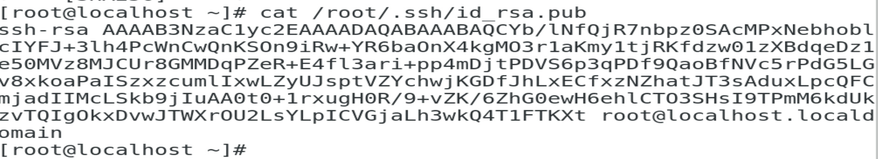

Keep your private key here at local and send public to github.com, to authorized your local workstation, for this go to github.com : login to account :

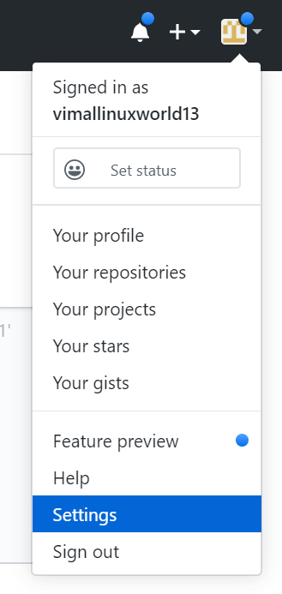

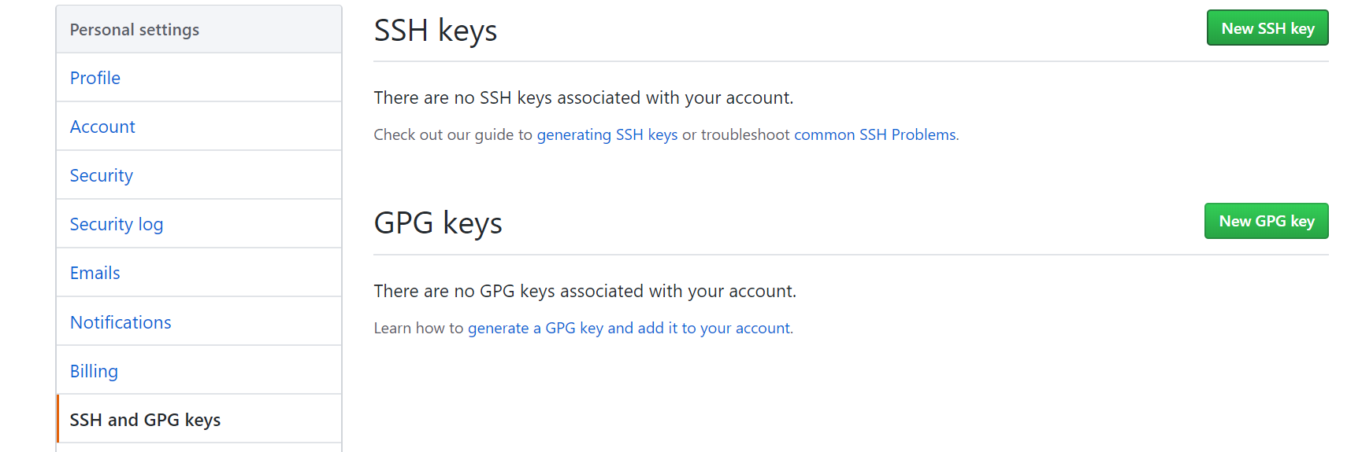

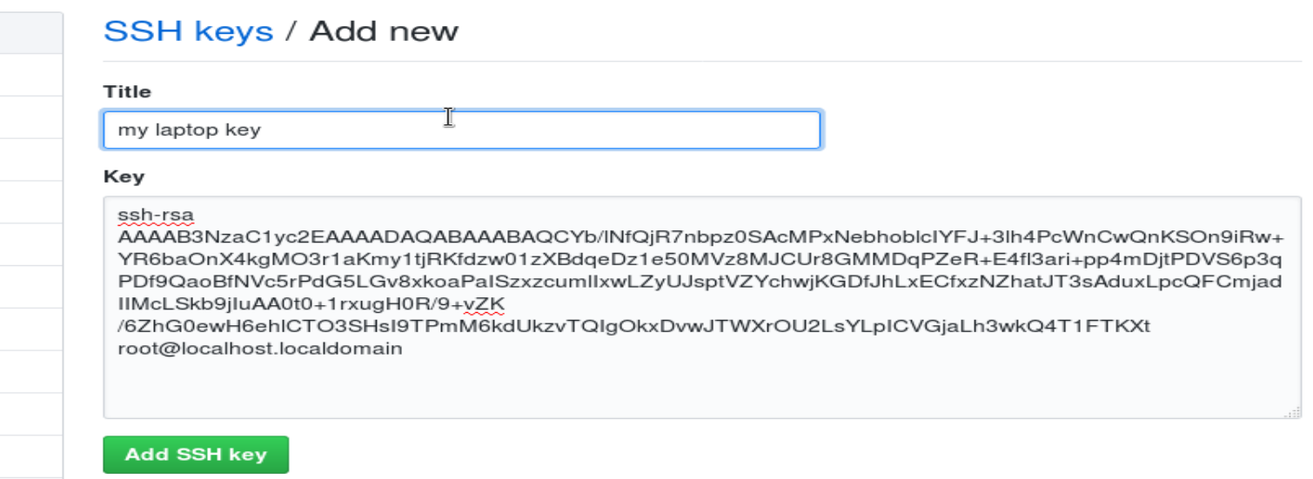

For testing, go to workstation:

**# ssh -T** [**git@github.com**](mailto:git@github.com)

Clone repo from github, to local system using SSH :

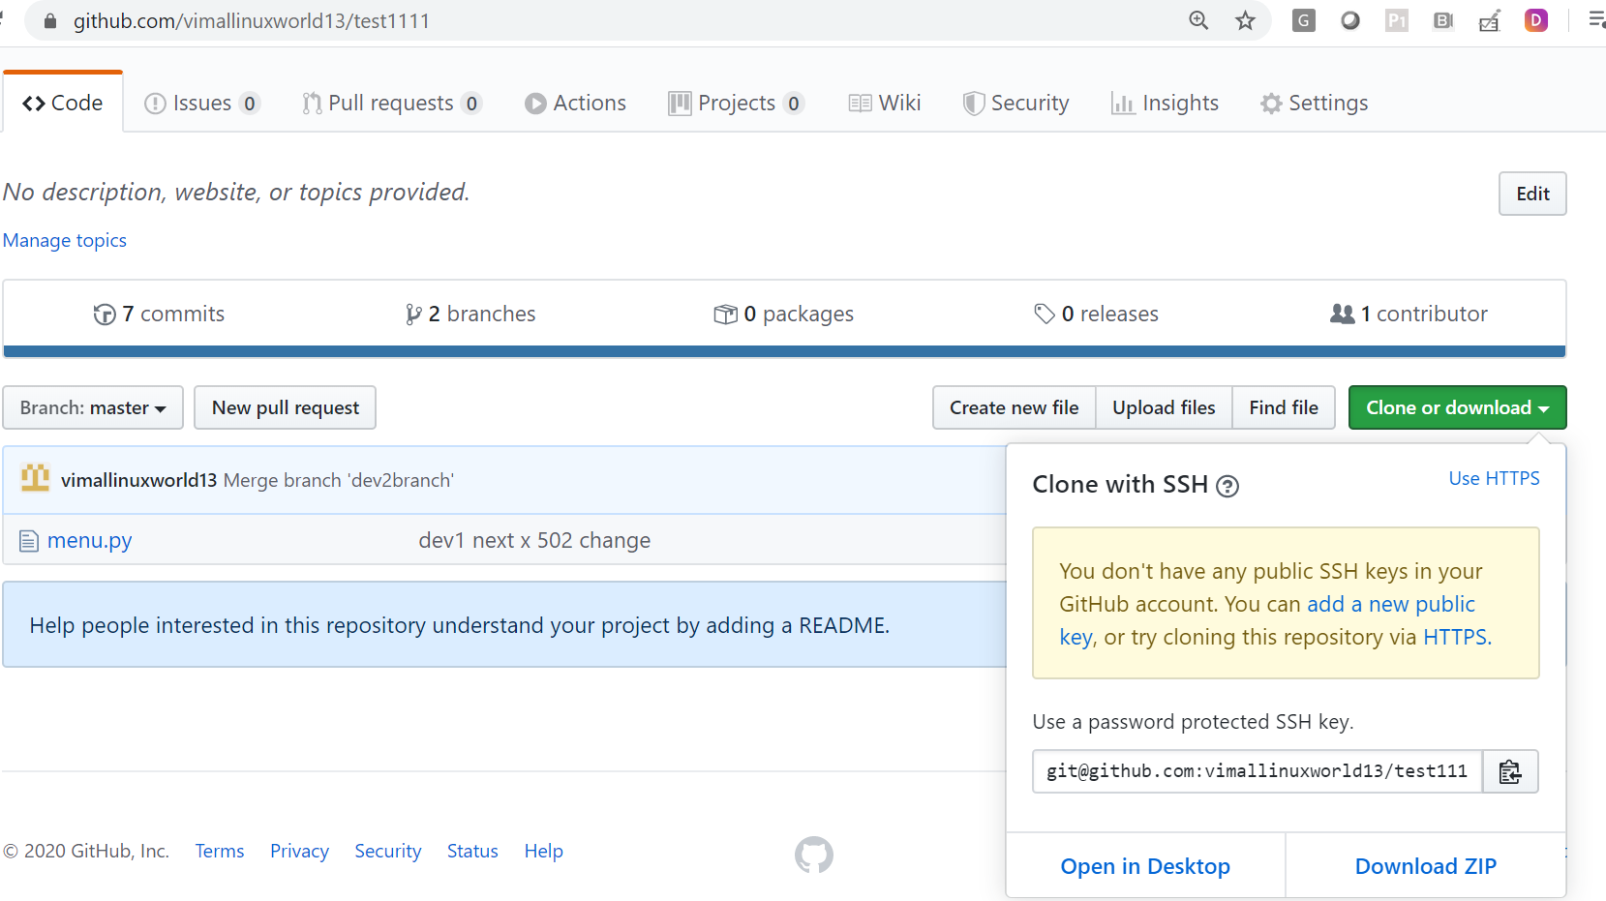

We are cloning from github to new dir called mylocalrepodir, it will clone without passphrase :

**# git clone** [**git@github.com**](mailto:git@github.com)**:vimallinuxworld13/test1111.git mylocarepodir**

------------------------------------------------------------------------------------------------------------------------

Change remote github repo name:

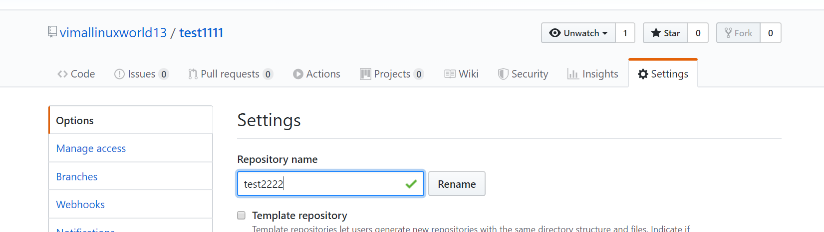

Change remote url in local repo:

**# git remote set-url origin** [**git@github.com**](mailto:git@github.com)**:vimallinuxworld13/test2222.git**

# git remote -v

**# git remote show origin**

Delete remote ref :

**# git remote remove origin**

**-------------------------------------------------------------------------------------------------------------------------**

Show data from repo at that particular point in time

**# git show commitID** (get from git log)

Create new branch from GITHub:

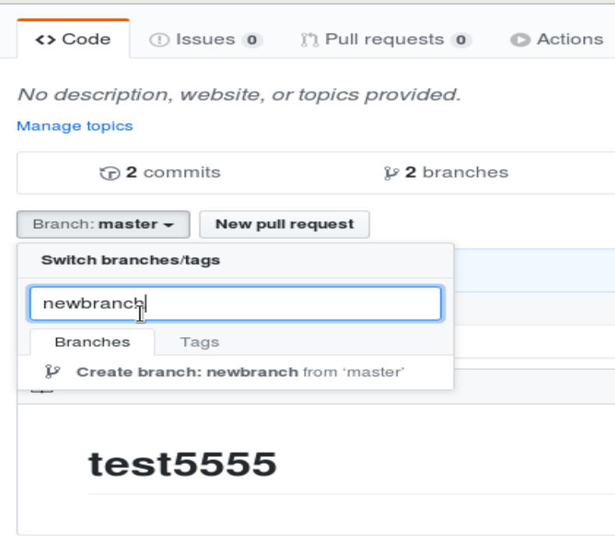

Create local branch and sync to github:

**# git checkout -b testbranch1**

It creates new branch in github:

**# git push -u origin testbranch1**

--------------------------------------------------------------------------

How to do pull request and merge in master branch from other branch in github :

Eg:

This is data in master branch:

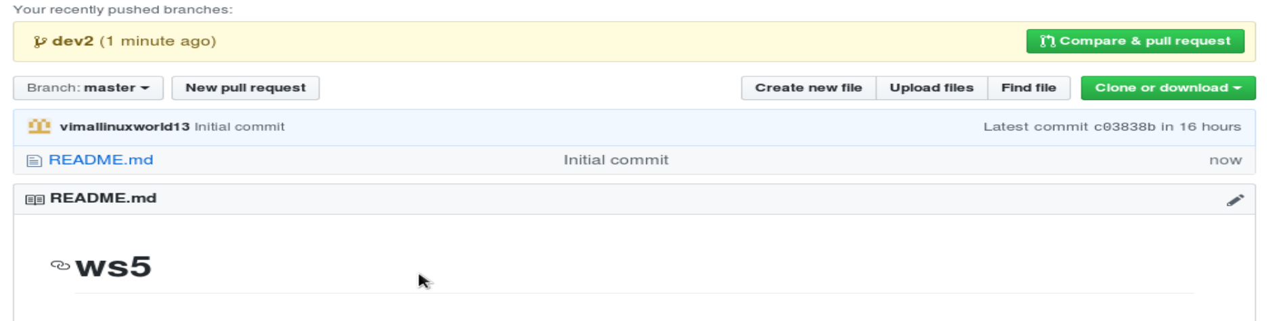

Other branch here, named dev2 changes data:

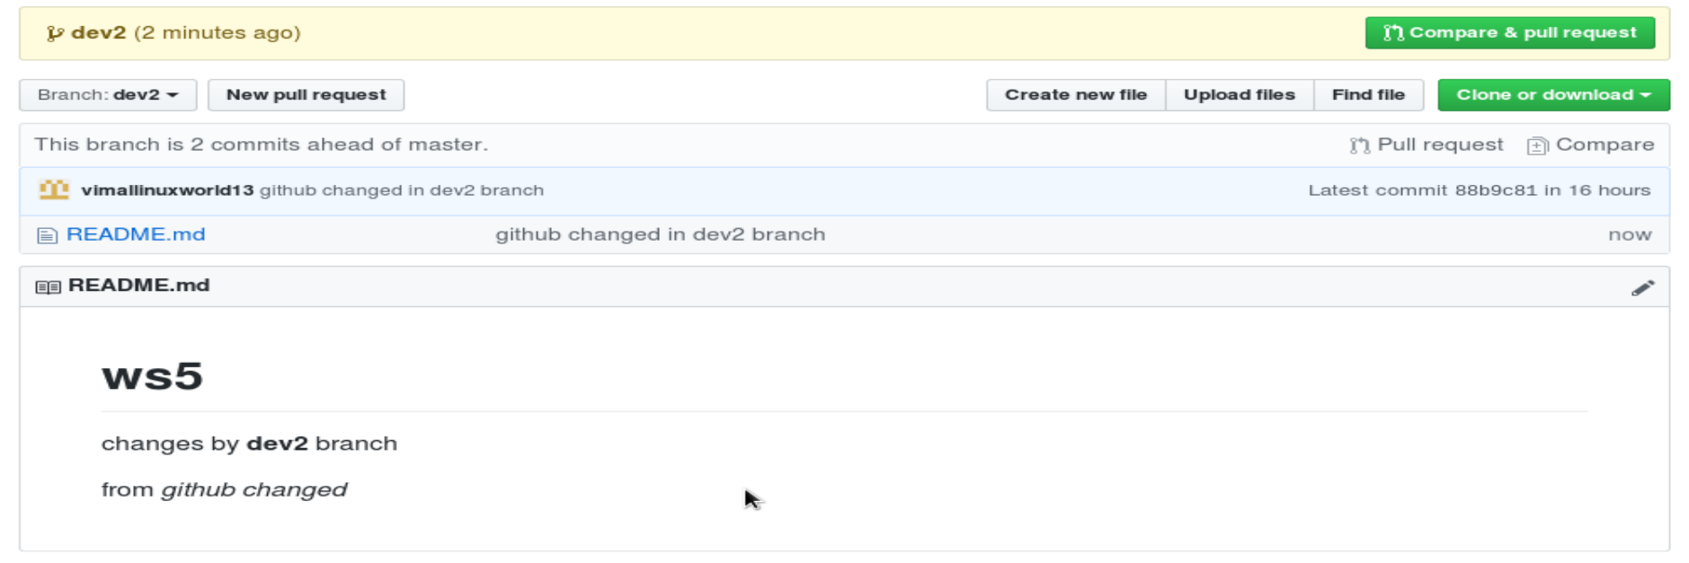

This shows, we have 2 branch ahead of master branch:

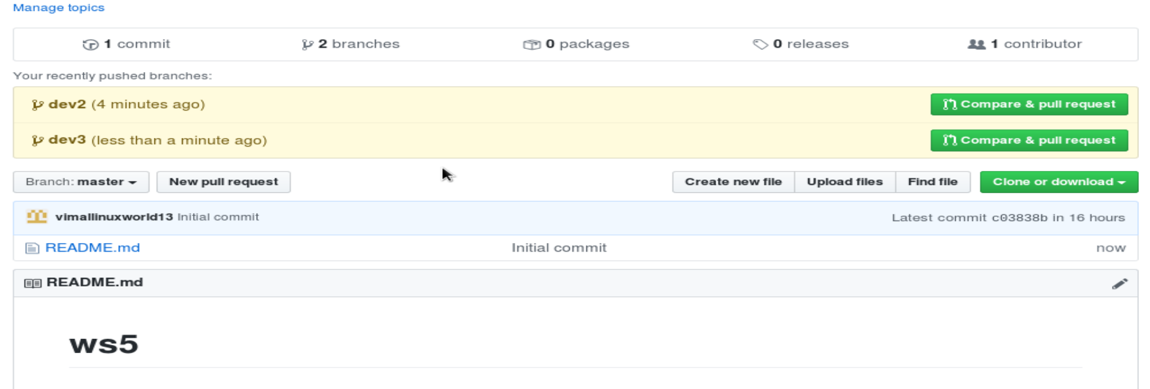

Now you can click on “compare and pull request” button, from where to get the merge in master branch, we are pulling from dev2 in master

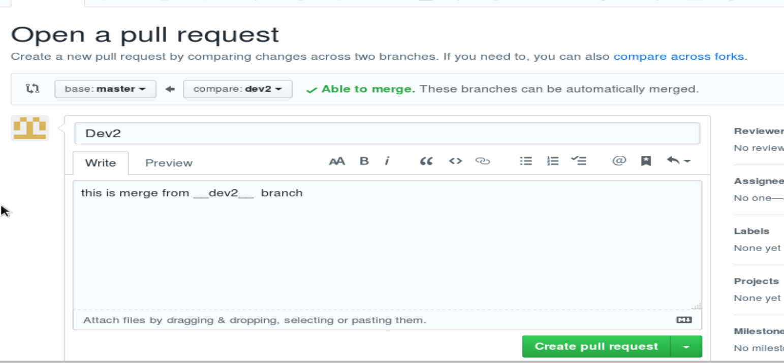

Finally merge from dev2 to master branch:

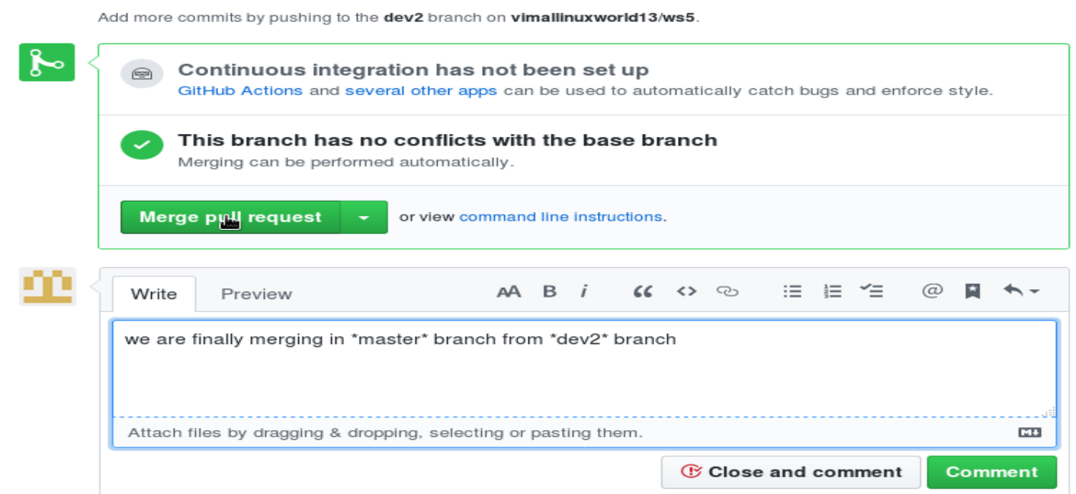

Finally in master branch, we merged from dev2 branch:

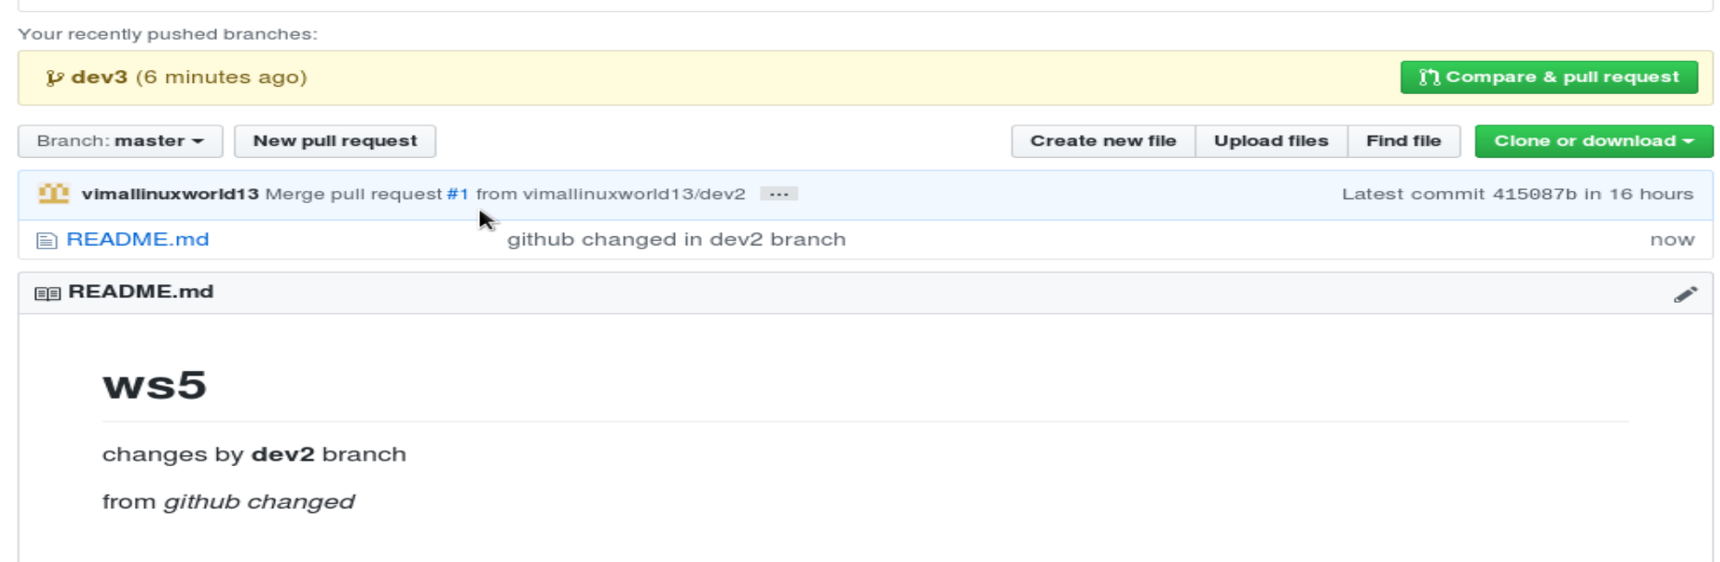

Example of merge conflict:

This is data in master:

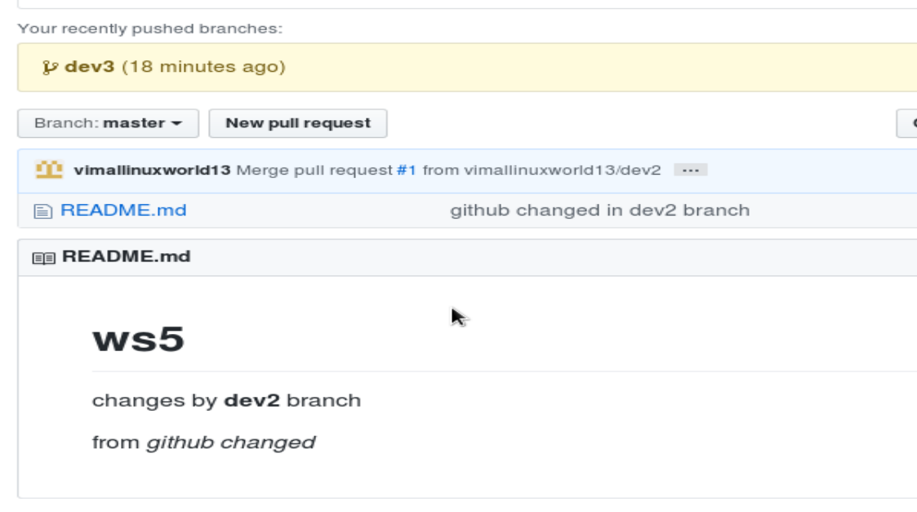

This is data in dev3 :

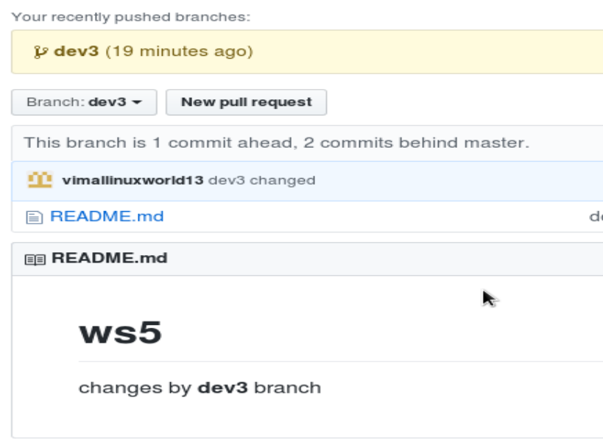

Now if we merge, it wont allow, as conflict :

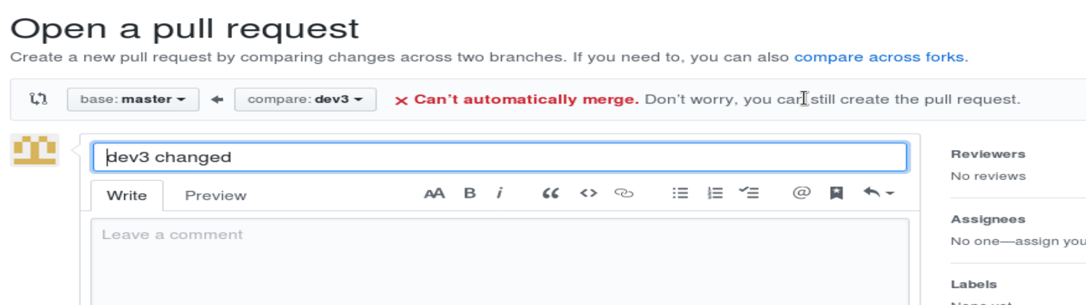

But we can request pull:

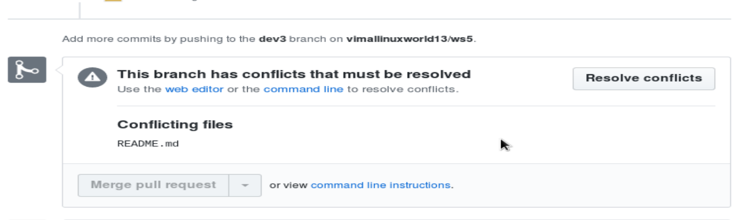

We have to do manual resolve, click resolve conflicts button

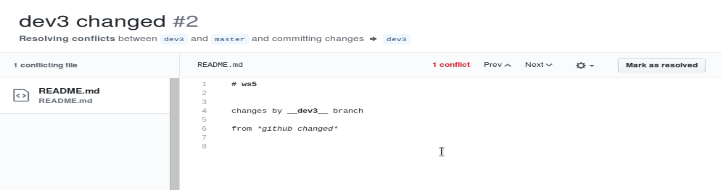

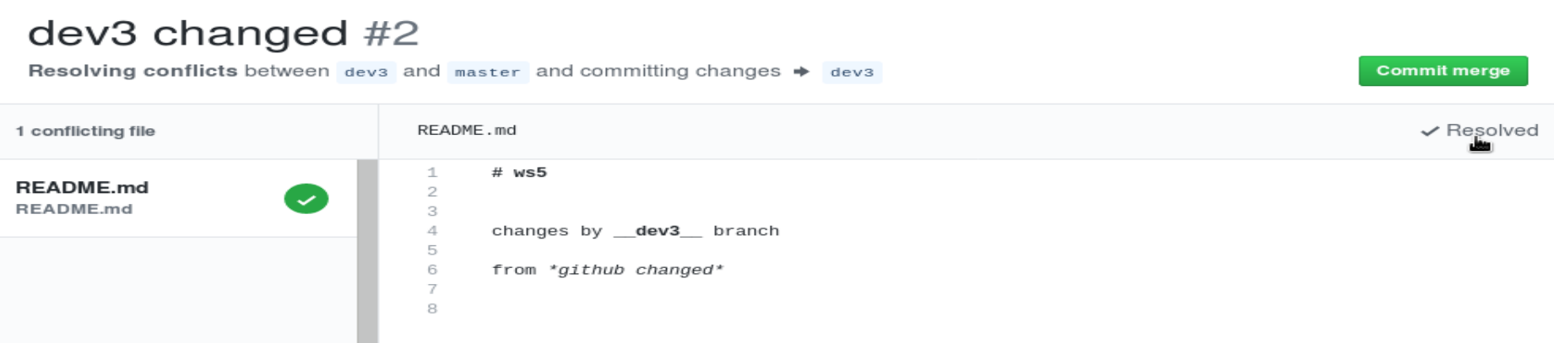

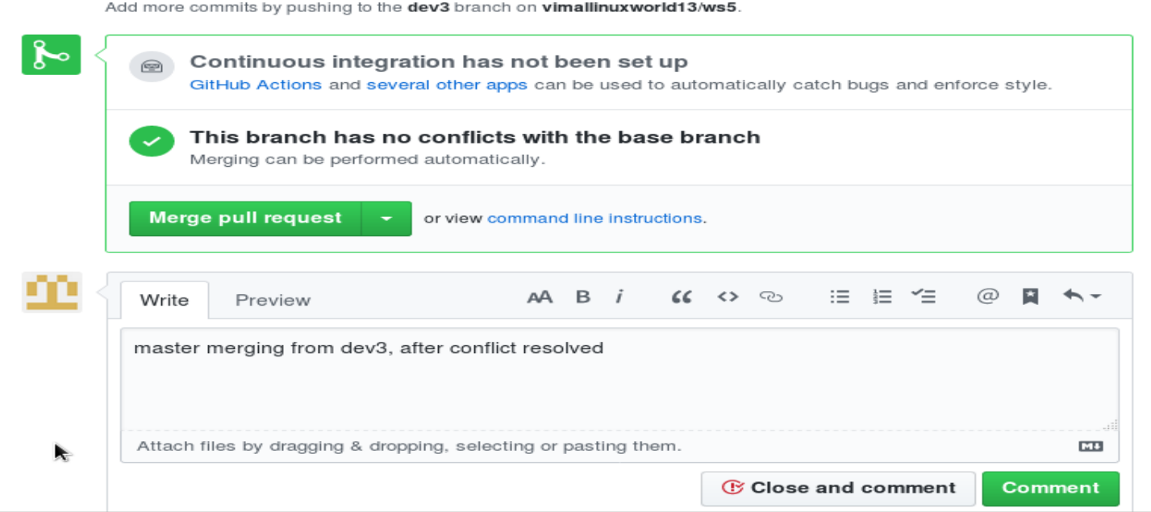

Get local repo synced from github:

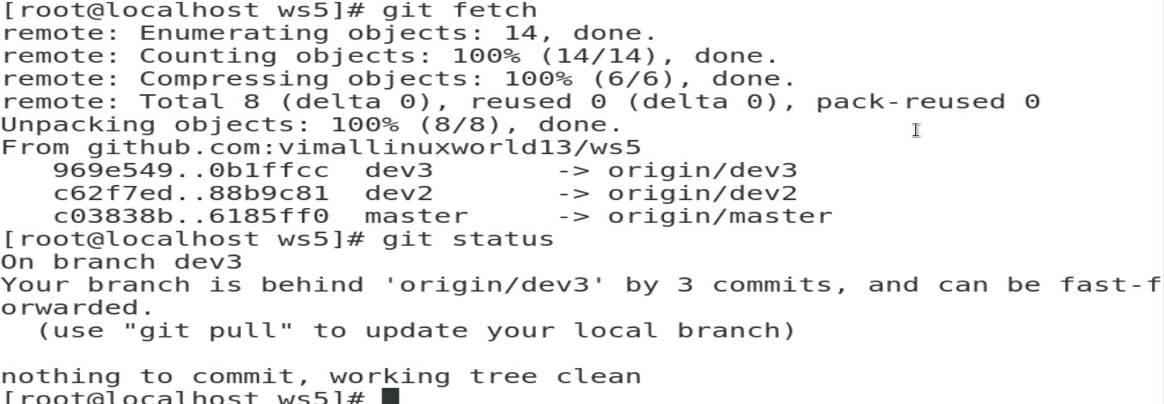

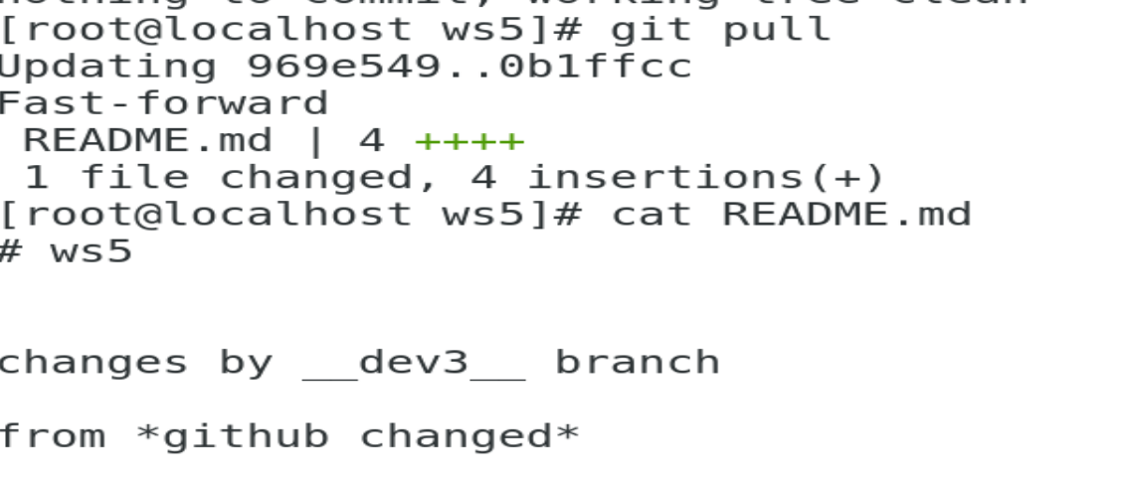

----------------------------------------------------------------------------

Remove branches “dev3” from github and update it ref to local:

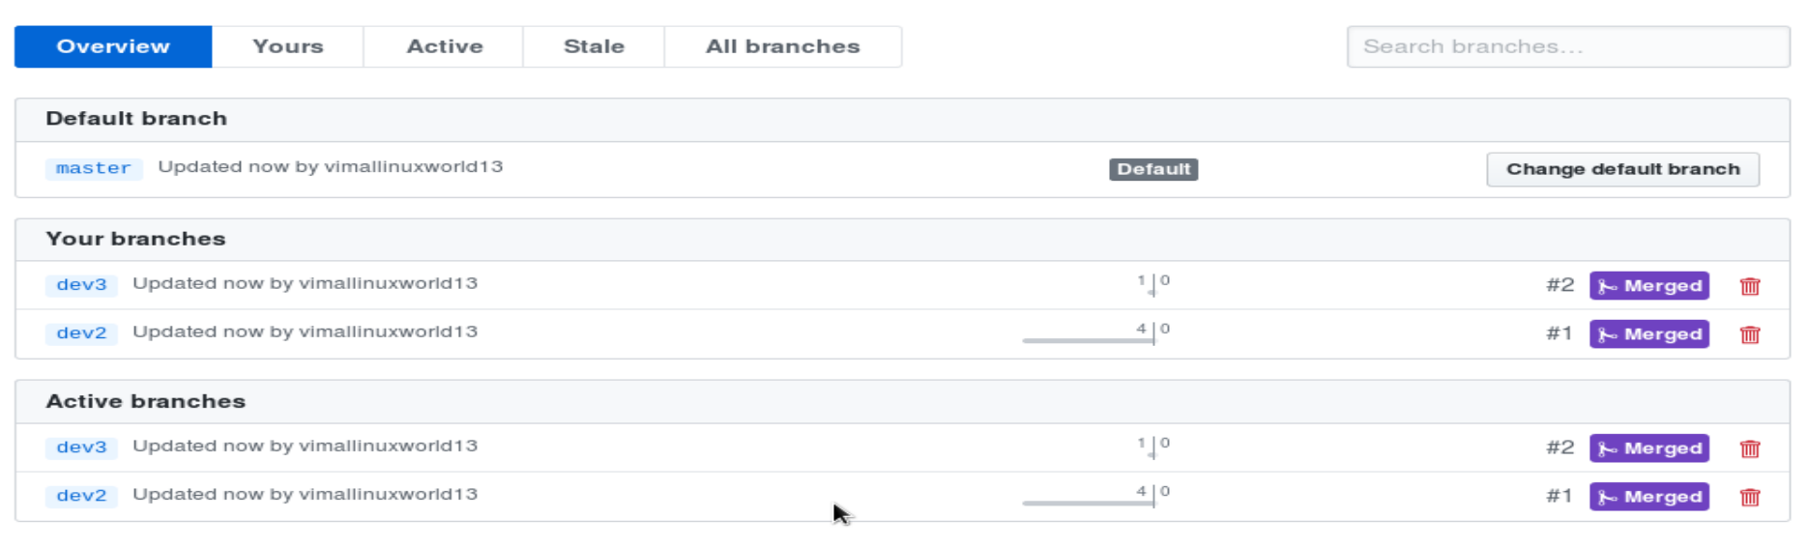

**# git branch -d dev3**

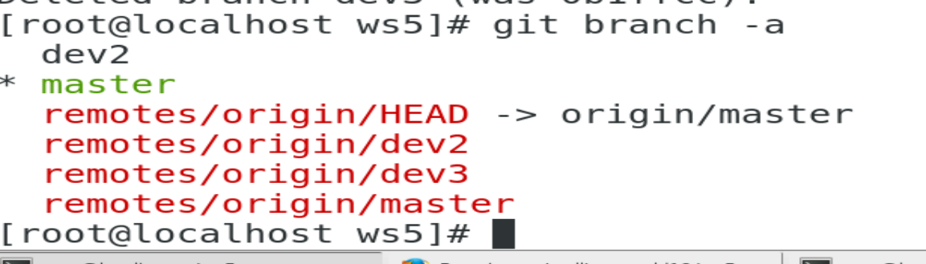

Remove ref of dev3 branch from local to origin (prune branch)

**# git fetch -p**

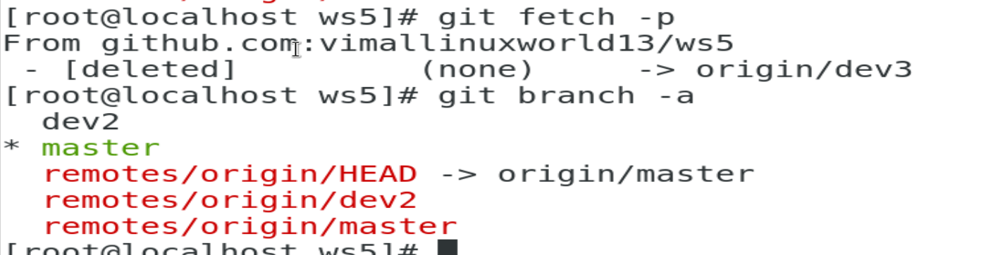

**---------------------------------------------------------------------------------------------------------**

How to sync branch create in github, synced with local repo:

Create example branch from github:

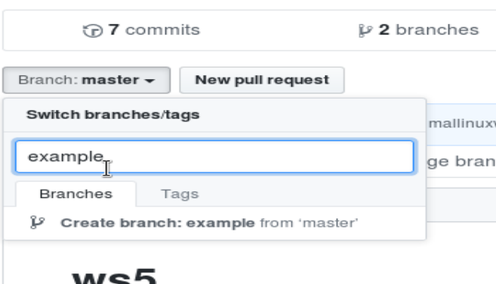

Changed in example branch:

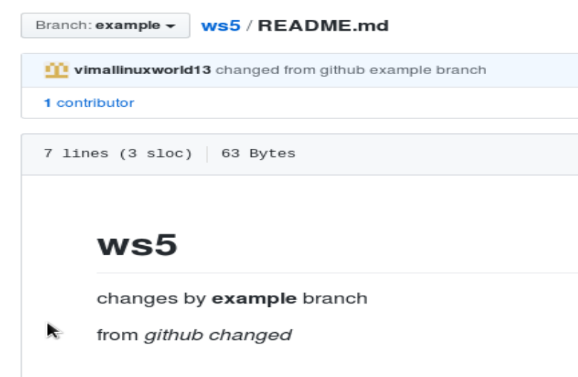

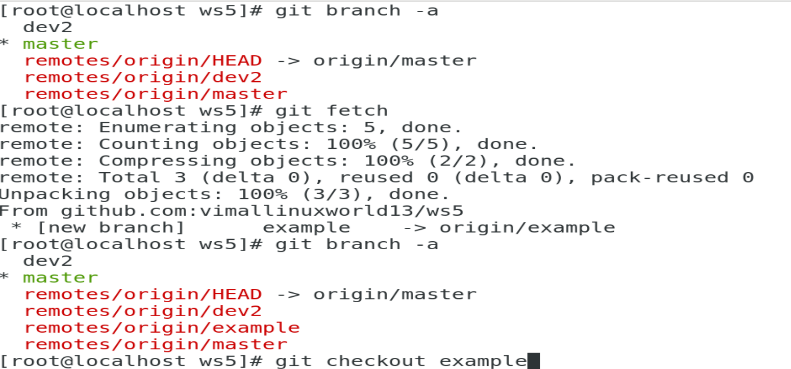

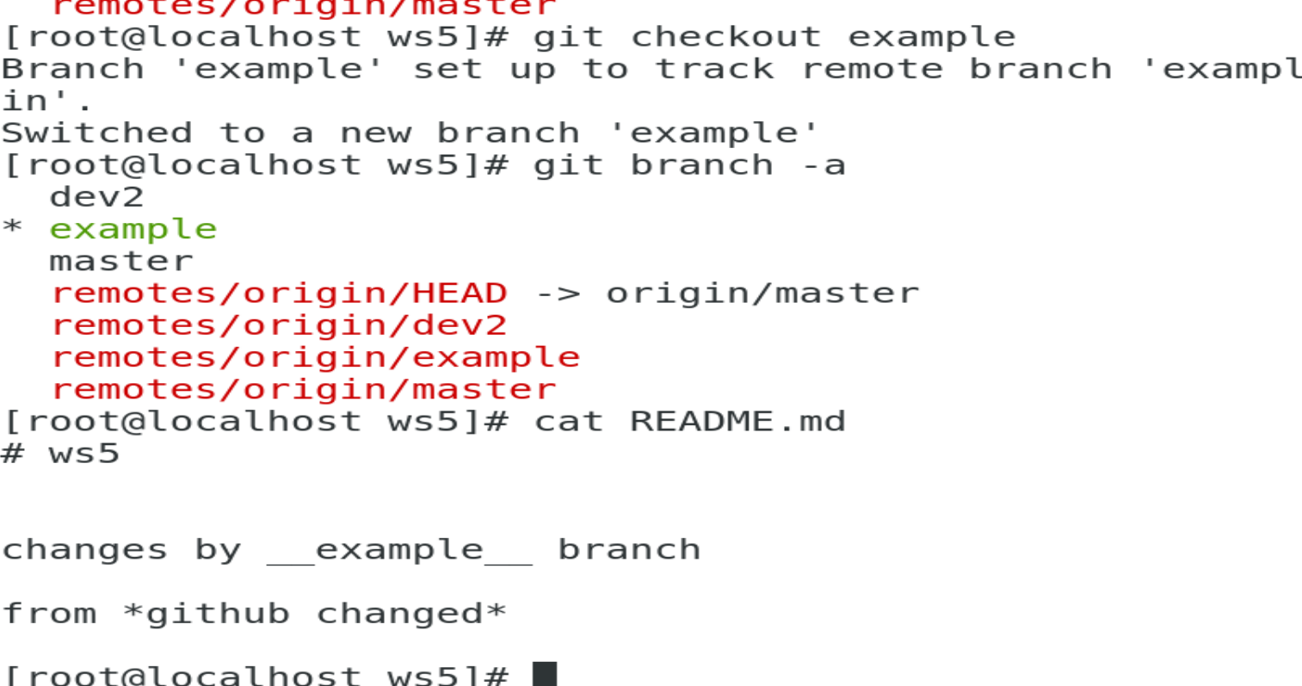

Here:

**# git checkout example**

Automatic create local branch and start tracking it

----------------------------------------------------------------------------------------------

Sync all repo data from all branch:

**# git pull --all**

Delete branch from local cli to github:

**# git branch -d example**

**# git push origin :example**

Note: here “:” means delete example branch

**---------------------------------------------------------------------------------------------------**

Git graph, show all commit and merge in all branches in graphical form :

**# git log --graph**

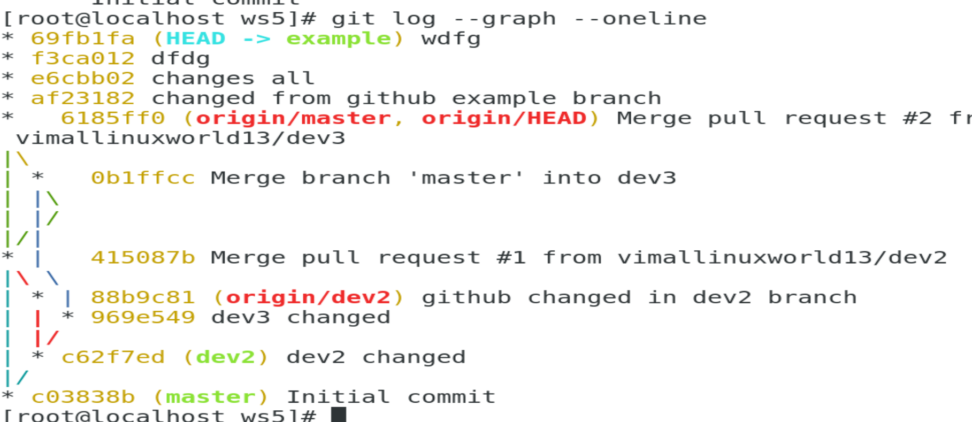

From github, graph (name changed to insight):

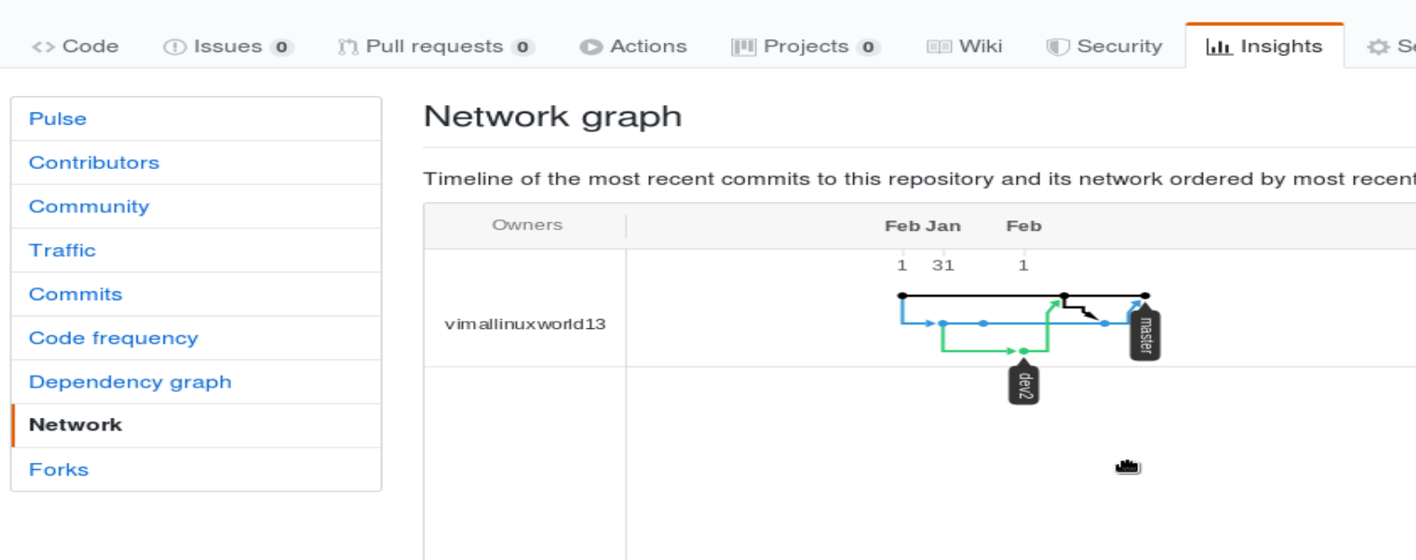

-------------------------------------------------------------------------------------------

How to change default branch:

Benefit of making other branch default:

* When do git clone, it get from other branch
* When we create other branch, it used base branch from that default branch
* It good for production use case, make production data comes from master branch, and all development work on that new default branch, so accidently nobody changes or merge in master branch

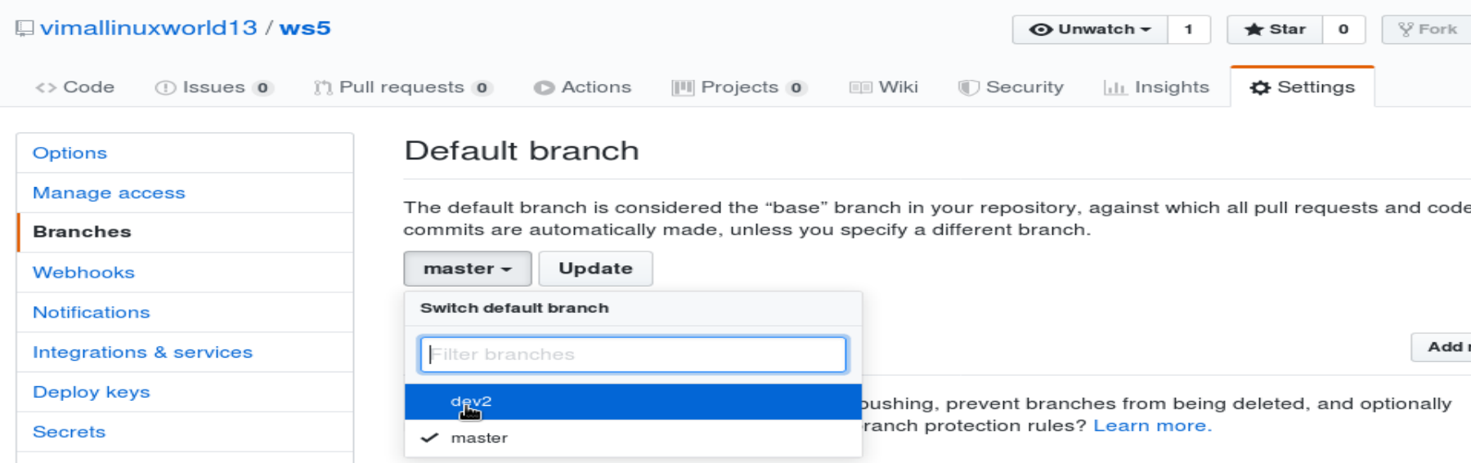

---------------------------------------------------------------------

When we have trouble of conflict with pulling :

This scenario, comes when we changed at github, then using “git fetch” at local, and before “git pull” , we changed locally and commit:

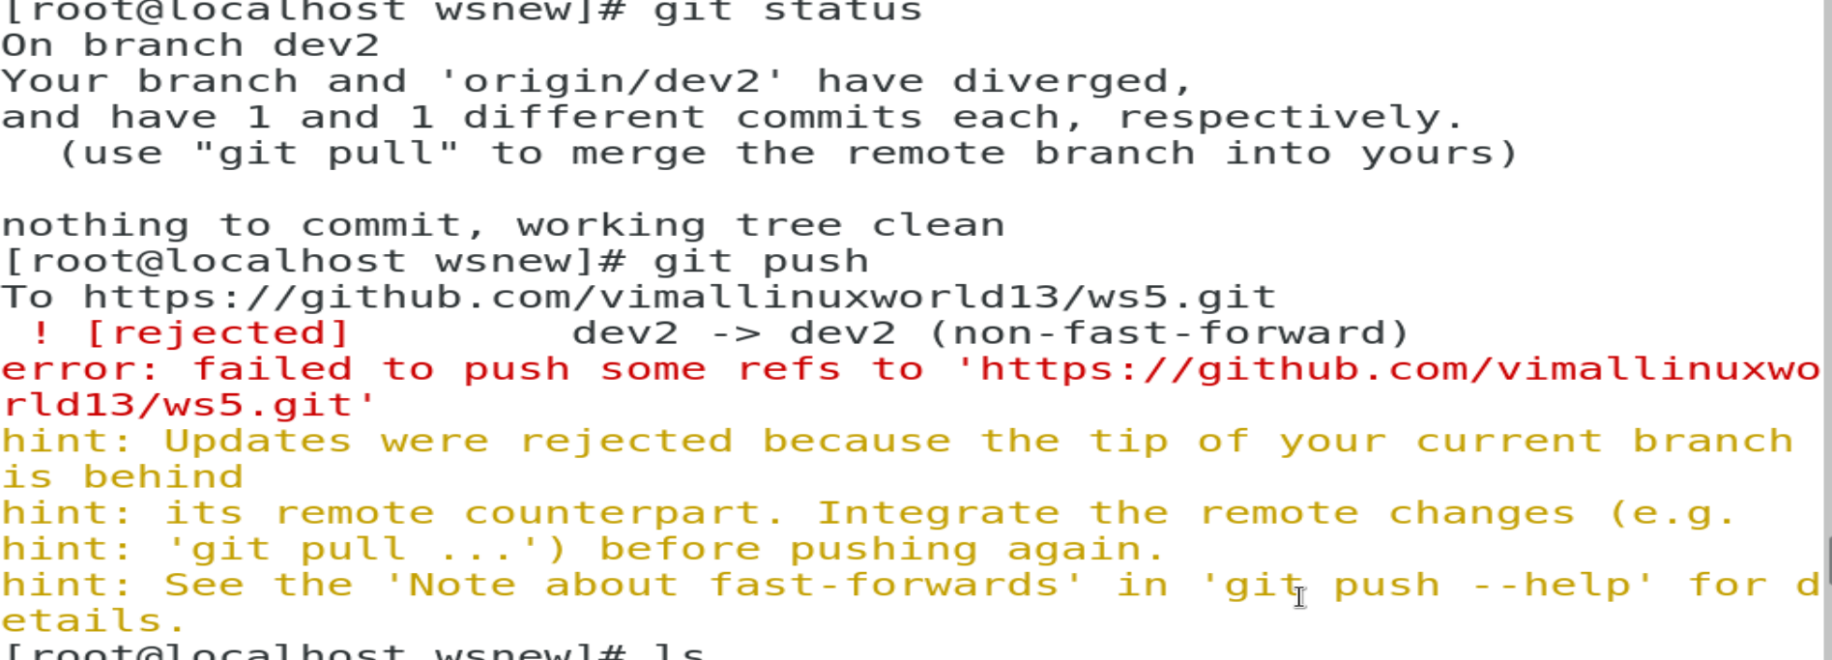



We have to use mergetool, to merge manually :





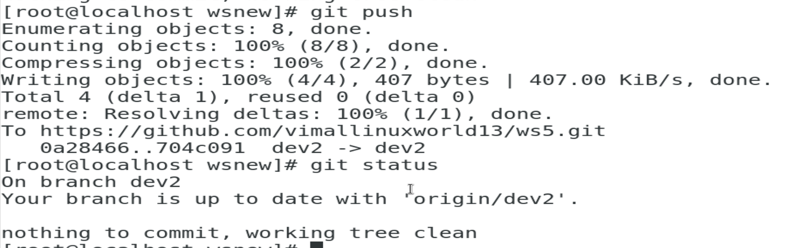

Steps to solve “diverged” conflict issue:

**# git pull**

**manual merge**

**# git mergetool**

**# git commit -m "comment"**

**# git push**

----------------------------------------------------------------------------------------

Get source branch or base branch(master) update into sec branch(dev1): rewind sub branch

In master branch:

# cat >> test.txt

Changes from master

# git commit -m “changed from master” .

# git checkout dev1

Get dev1 updated data from master branch (something like opposite of merge):

**# git rebase master**

# cat test.txt (sec branch dev1 get updated data from master branch)

In conflict of rebasing:

# git rebase --abort

# git mergetool

# git add .

# git commit

# git rebase --continue

If local repo and git hub changes and commit, and we want to update local repo from github, before it push to github:

**# git pull --rebase origin master**

**# git push**

----------------------------------------------------------------------------------------------------------------------------

If we don't want to commit changes in file, as we are in work in progress(WIP), but want to save state of file, and want to work in other file to commit changes :

**# git stash save**  (or git stash)

# git stash list

Go back to the same state, where we saved file, to continue your work from there

**# git stash apply**

# git stash drop

Stash doesnt stash untracked file by default , if you want to stash all file from staging and working area:

**# git stash -u**

And to apply and drop in single command, we can use “pop”:

**# git stash pop**

If we want to create multiple stash, having multiple WIP :

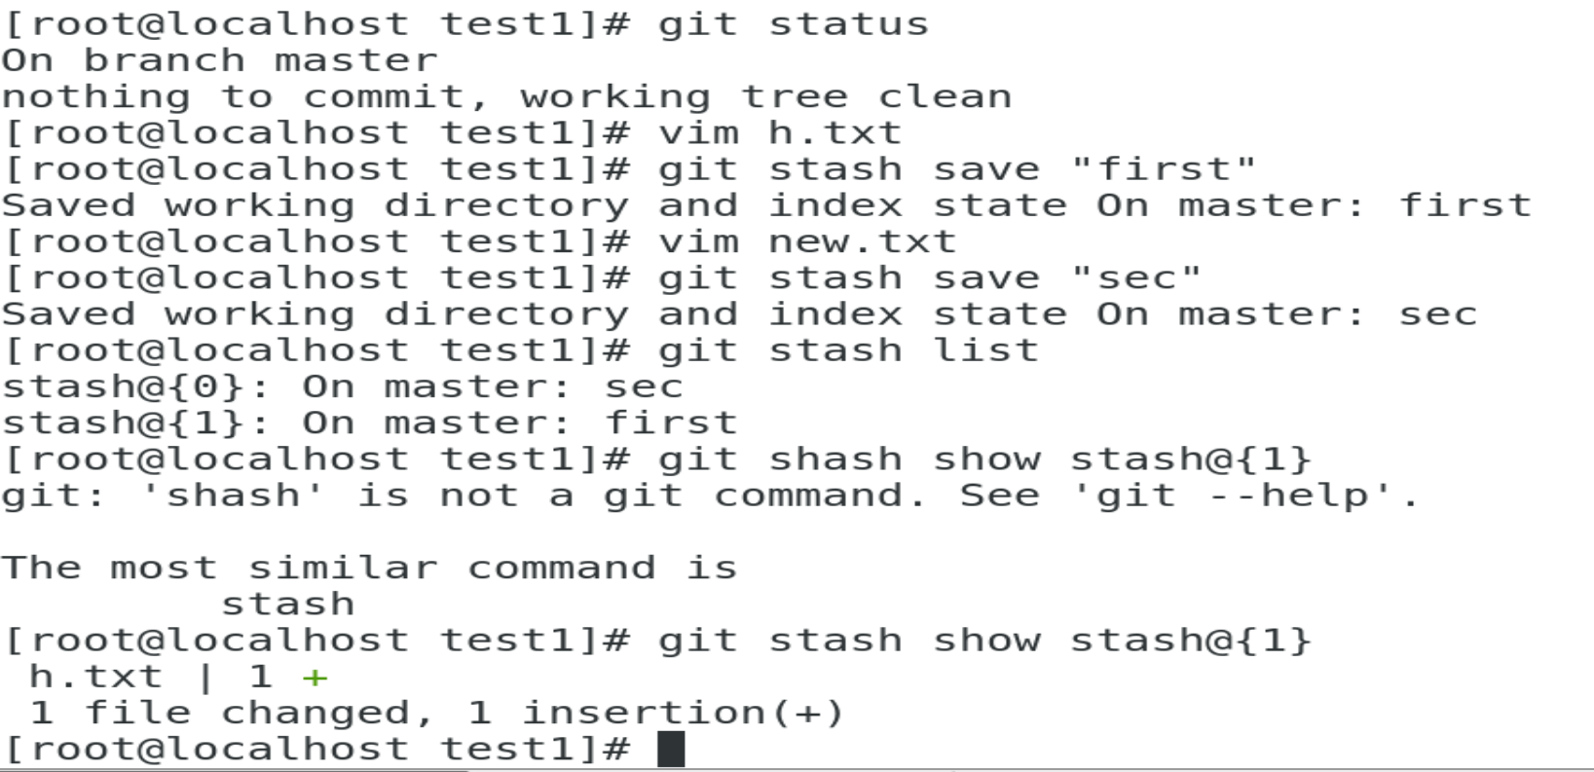

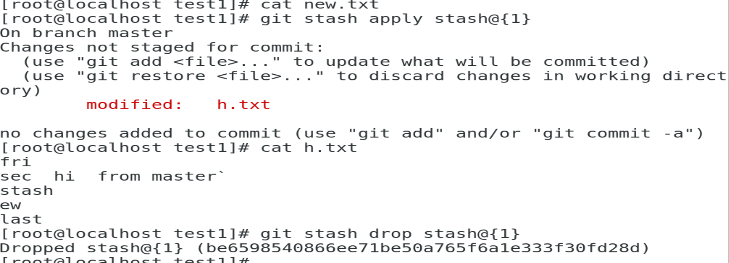

Clear all stash, also remove all WIP data:

**# git stash clear**

If you changed or create something in master branch, then release it might create issue in code, then we can take all these changes to new branch, and make master branch clean:

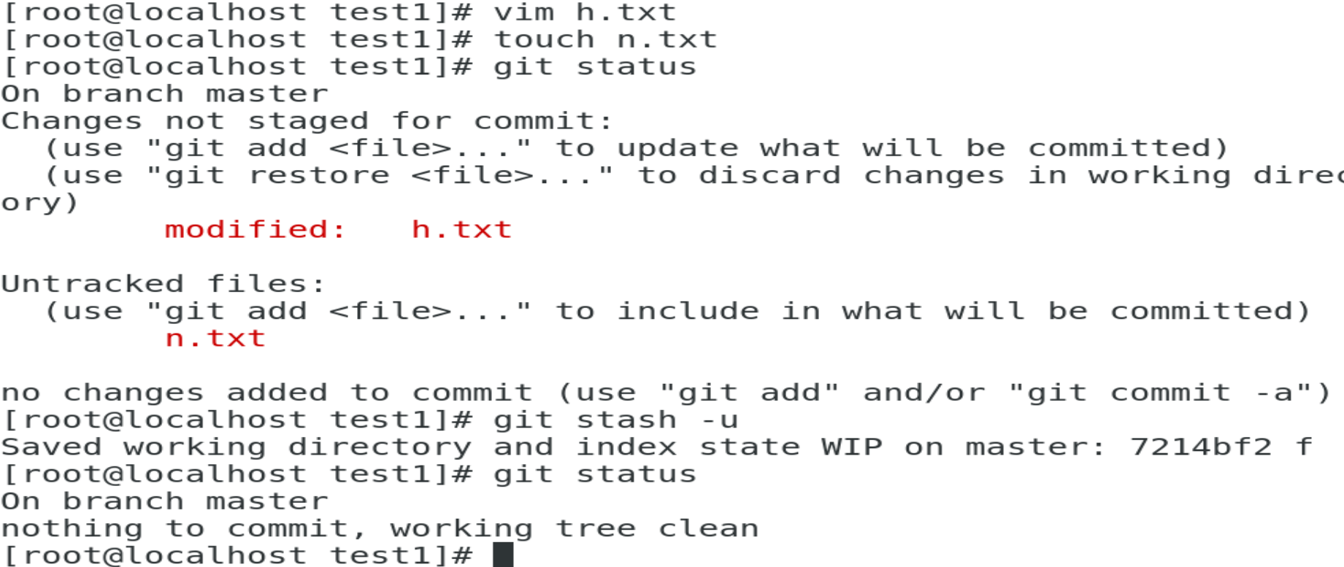

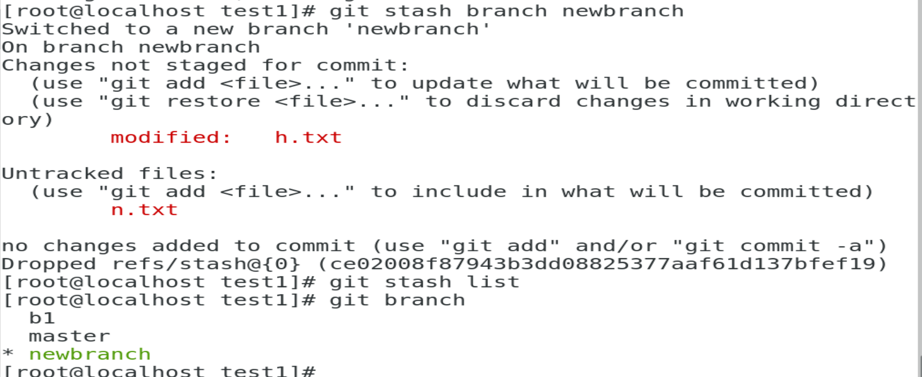

**------------------------------------------------------------------------------**

How to amend previously committed ID, new data or files:

Always good practise to do in new branch, as while doing amend, it changes commit ID:

# git checkout -b newb

**# git commit --amend -m “new changes”**

Its shows only reachable history:

**# git log --oneline**

But if we want to see all history, even that is unreachable because of amend:

**# git reflog**

To get and start working again in orphaned branch:

# git checkout commitID

# git checkout -b newbranch

Go to history at particular time:

**# git reflog HEAD@{2.days.ago}**

**# git reflog master@{2020-01-13}**

**# git diff HEAD@{2} HEAD@{3}**

# git reflog expire --expire-unreachable=now --all

# git gc --prune=now

----------------------------------------------

Git GUI client :

-----------------

<https://www.gitkraken.com/download>

-------------------------------------------------------------------------------------------------------------------------------

Install GIT bash for windows:

<https://git-scm.com/downloads>

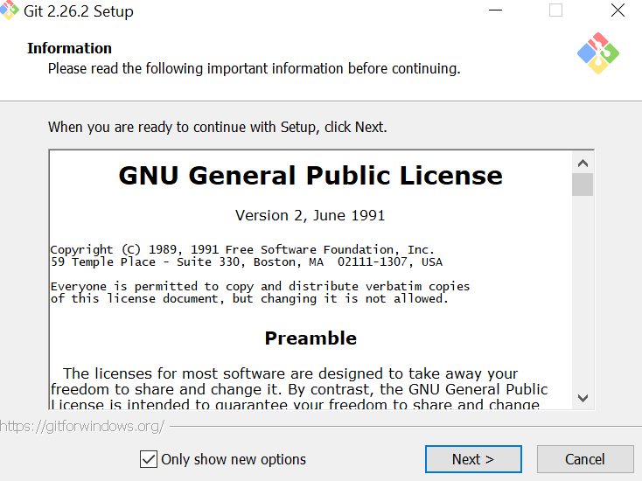

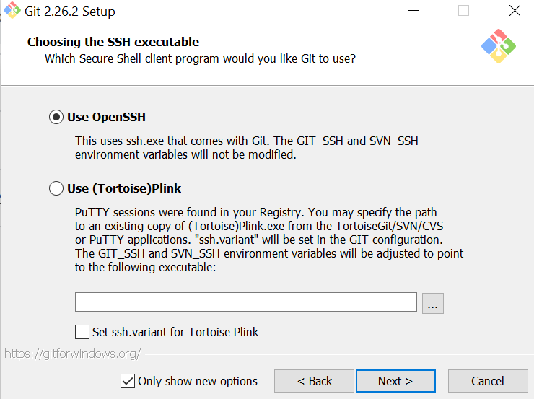

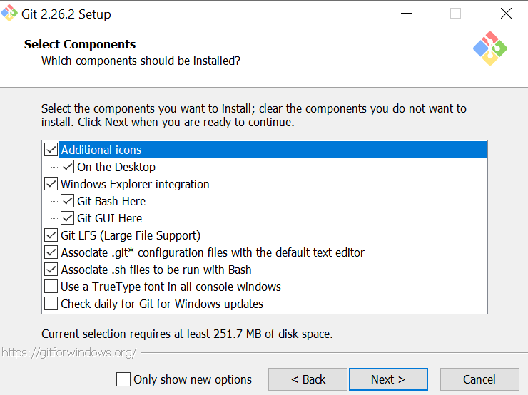

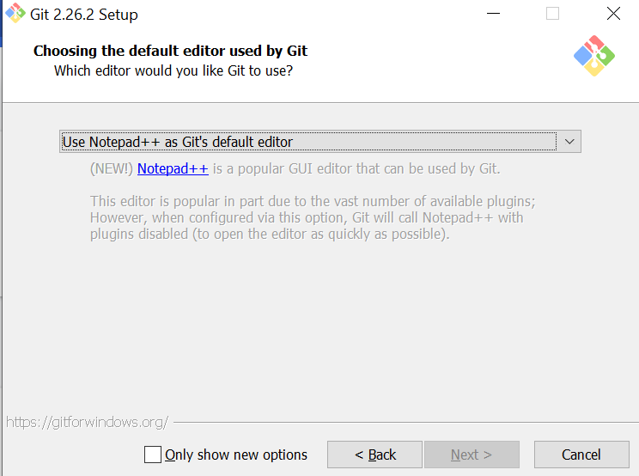

<https://notepad-plus-plus.org/downloads/v7.8.6/>

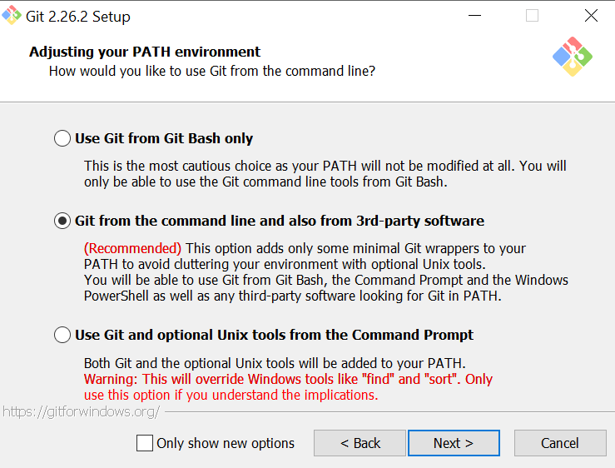

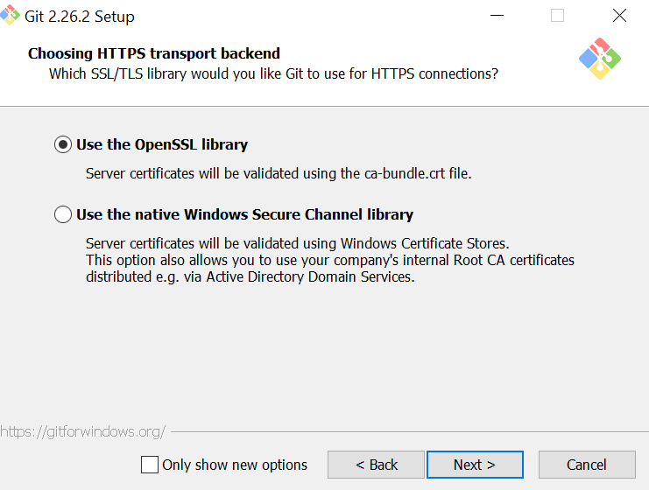

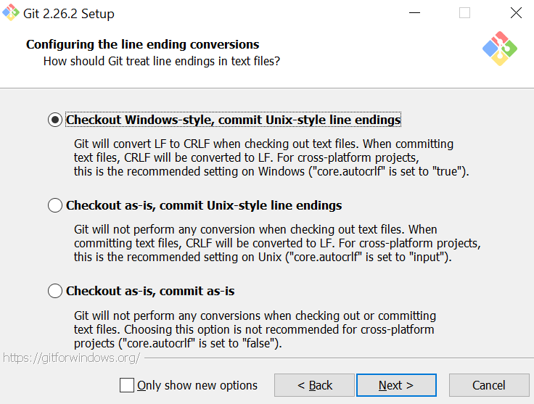

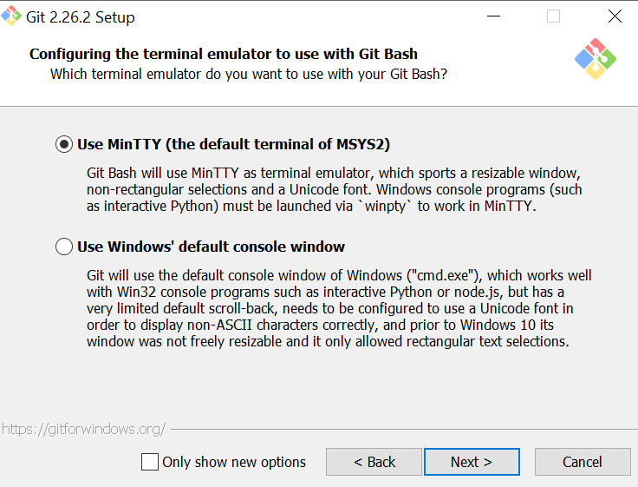

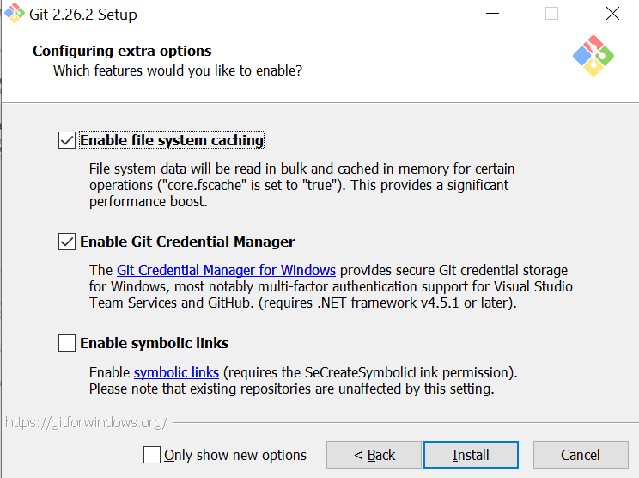

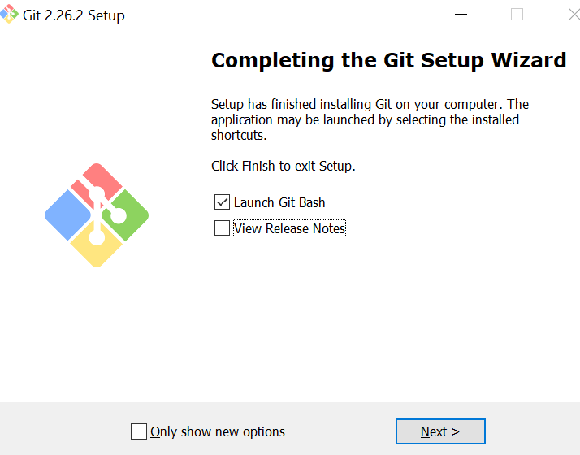

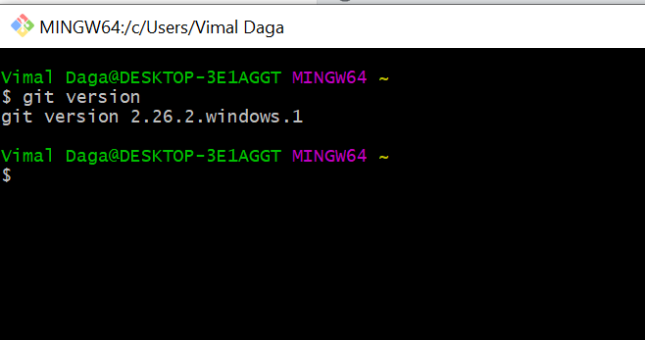

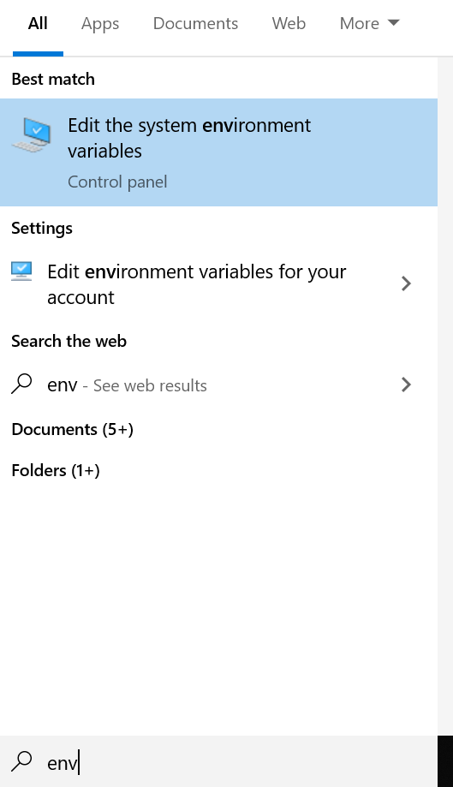

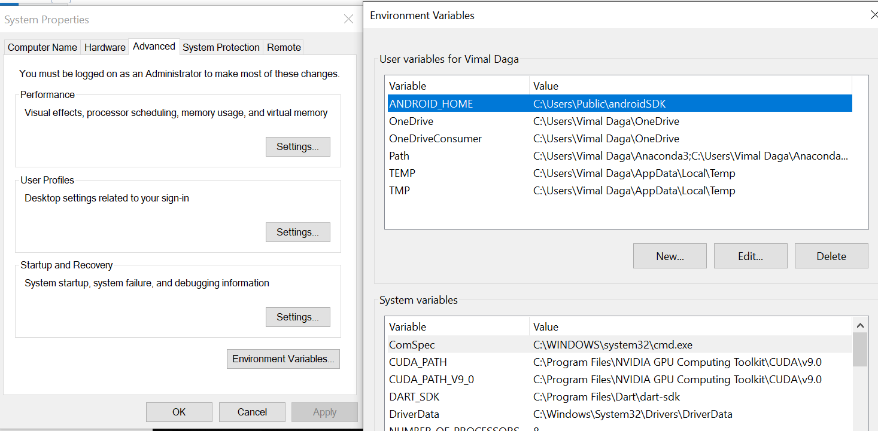

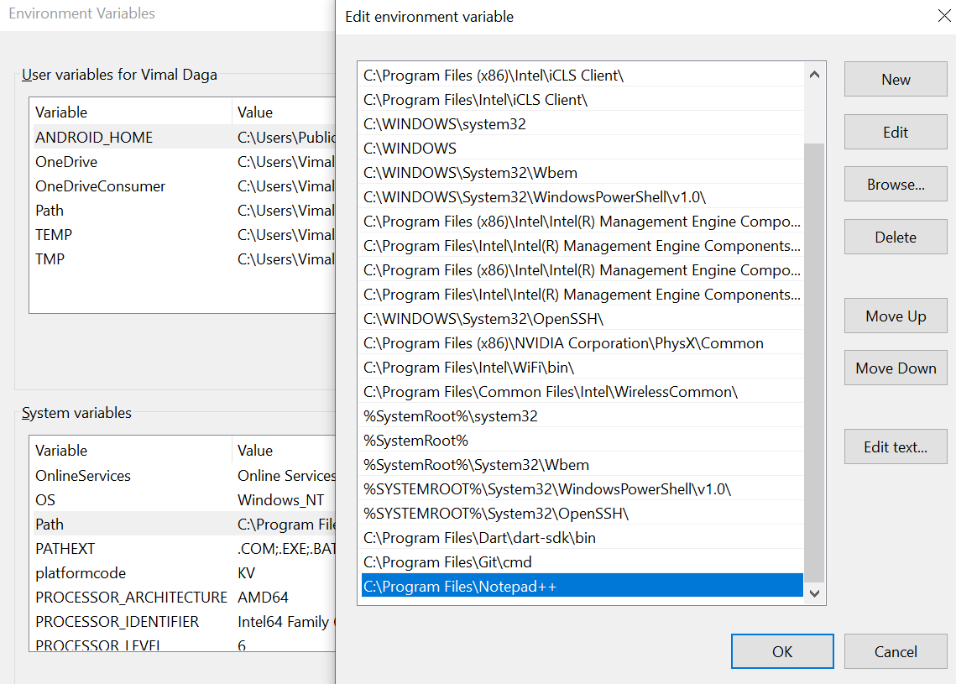

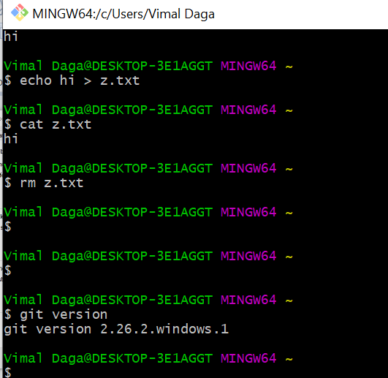

--------------------------------------------------------------------------------------------------------------------------

Create Repo in GIThub:

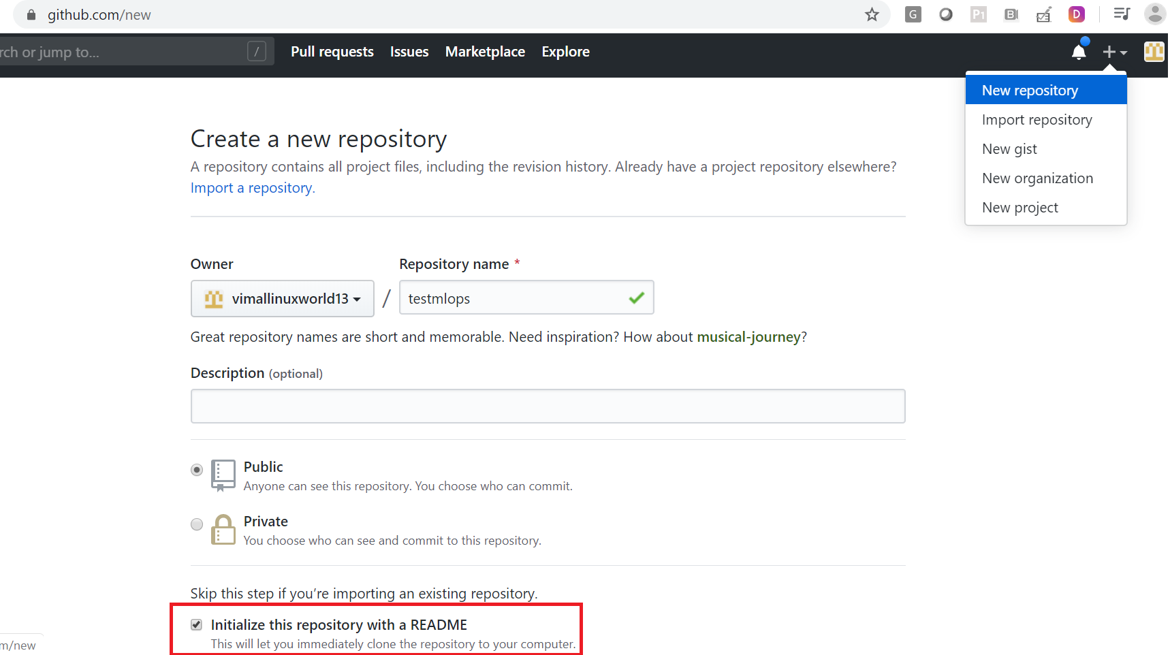

----------------------------------------------------------------------------------

Remove https url and change to ssh:

# ssh-keygen.exe

# cat homedir/.ssh/id_rsa.pub

Add public key into : github -> setting -> ssh and gpg keys -> new ssh key

Test Connection:

# ssh -T [git@github.com](mailto:git@github.com)

# git remote -v

# git remote remove origin

# git remote add origin [git@github.com](mailto:git@github.com):vimallinuxworld13/testmlops.git

# git remote show origin

# git push --set-upstream origin master

# git remote show origin

----------------------------------------------------------------------------------------

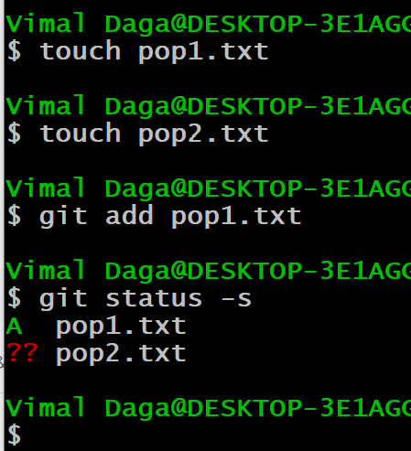

# git config --list --show-origin

# git clone https://github.com/vimallinuxworld13/test1234.git --branch dev1

$ git config --global --unset user.email

$ git config --global --unset user.name

$ git config --global --list